Lab 2 – COVID version

Objectives

* Make sure Quartus Prime and tools are installed
* Verify joystick and buttons work with DE10-Lite board
* Understand how to get a project setup in Quartus Prime Lite.
* Understand how to use pin planner and assignment editor and configuration settings
* Understand how to use ADC IP.
* Understand terminology for ADC IP

Note

You should use the datasheets and course materials first. You can also use the internet, but your final work should be your own. If you copy and paste from the internet you will receive a zero for the entire assignment.

Here’s a couple items that might be useful in answering the questions in this lab.

# DE10-Lite User Manual

<https://www.terasic.com.tw/cgi-bin/page/archive_download.pl?Language=English&No=1021&FID=a13a2782811152b477e60203d34b1baa>

# Intel® MAX® 10 Analog to Digital Converter User Guide

<https://www.intel.com/content/dam/www/programmable/us/en/pdfs/literature/hb/max-10/ug_m10_adc.pdf>

# Intel MAX 10 FPGA Device Overview

<https://www.intel.com/content/www/us/en/programmable/documentation/myt1396938463674.html>

# Intel MAX 10 General Purpose I/O User Guide

<https://www.intel.com/content/www/us/en/programmable/documentation/sam1393999966669.html>

# Intel MAX 10 FPGA Device Datasheet

<https://www.intel.com/content/www/us/en/programmable/documentation/mcn1397700832153.html#mcn1397644005799>

# MAX 10 FPGA Device Architecture

<https://www.intel.com/content/www/us/en/programmable/documentation/sss1397439908414.html>

## Initial Setup & Pin planner

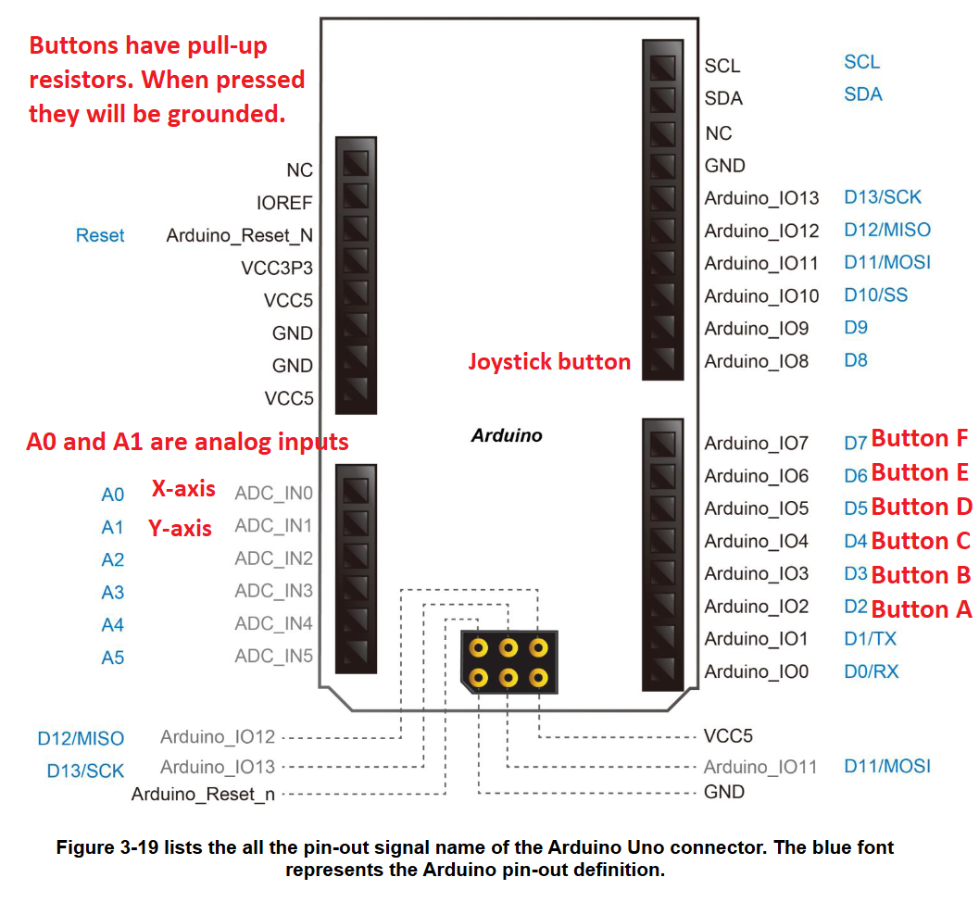

1. Unzip the template folder to a location you can save.
2. Open Quartus Prime Lite
3. Go to File and open project.

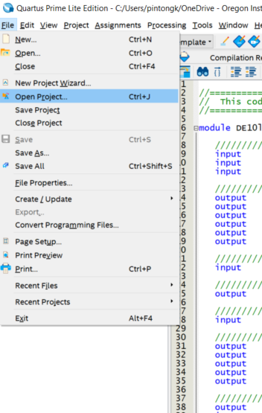

1. Open up the QPF template file.

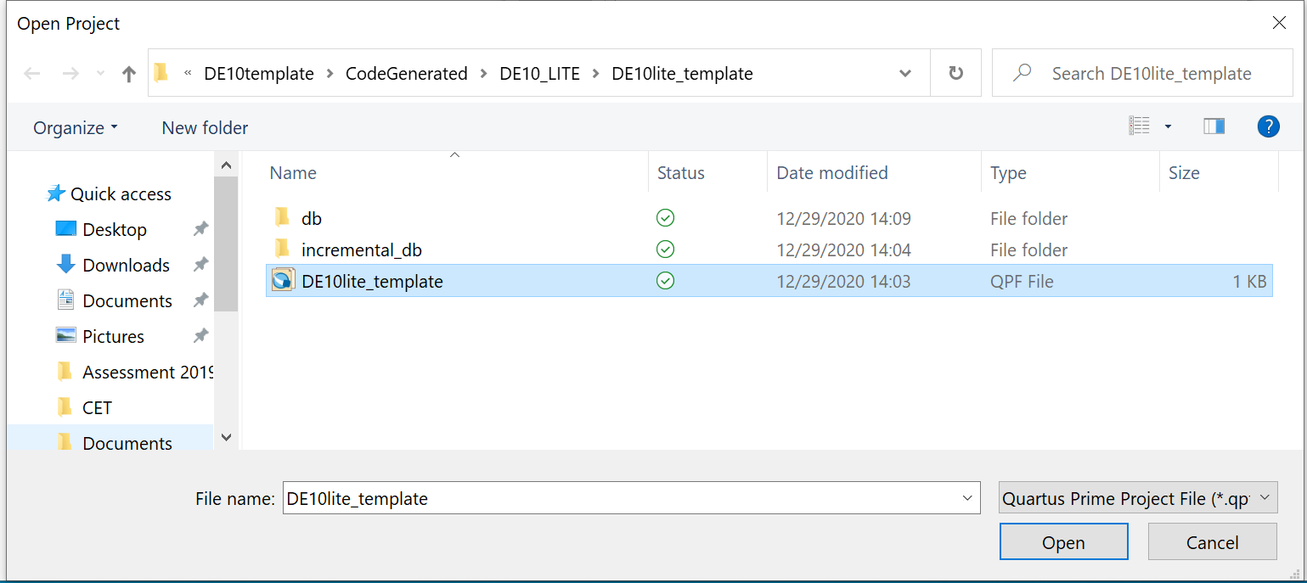

1. It should launch the template with the DE10lite_template. Double click on it and it should launch the DE10lite_template.v file.

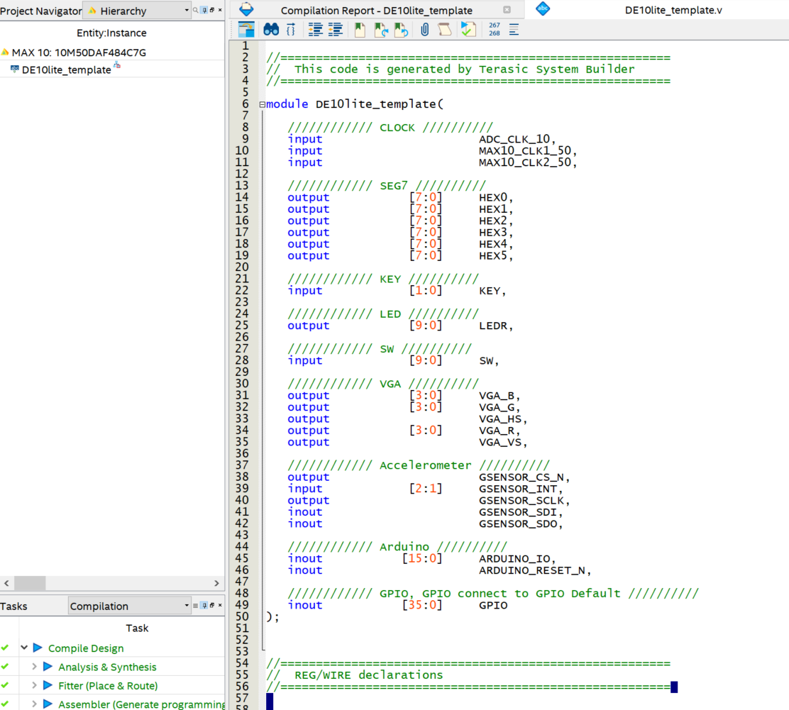

1. Click on Assignments > Pin Planner

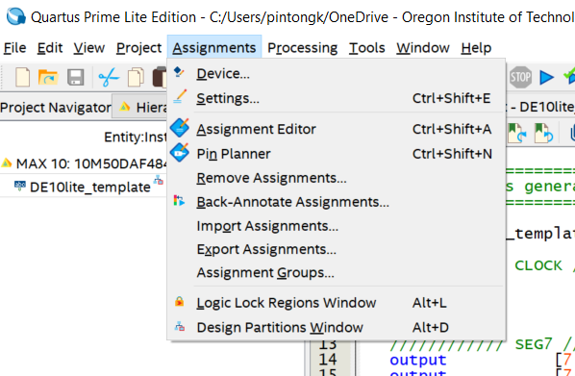

1. Something like this should launch. This is essentially the pinout on the BGA of the MAX10 device on the DE10-Lite board. You can see there are different pins such as ground, differential pair, and different power banks.

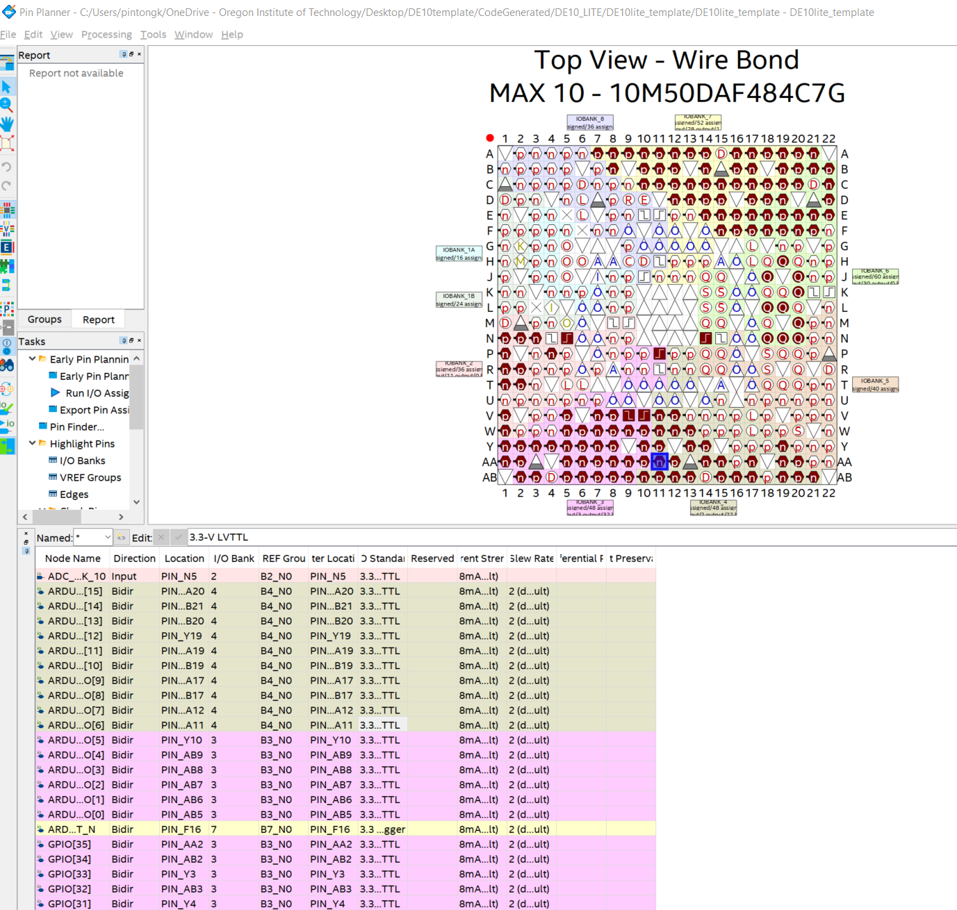

1. This is where you can change Node names, change the pin that you map a specific name to, change the direction (input, output, bidirectional), change the IO standard, slew rate.
2. Now, let’s exit out of Pin Planner and go to Assignments > Assignment Editor in the main quartus window.

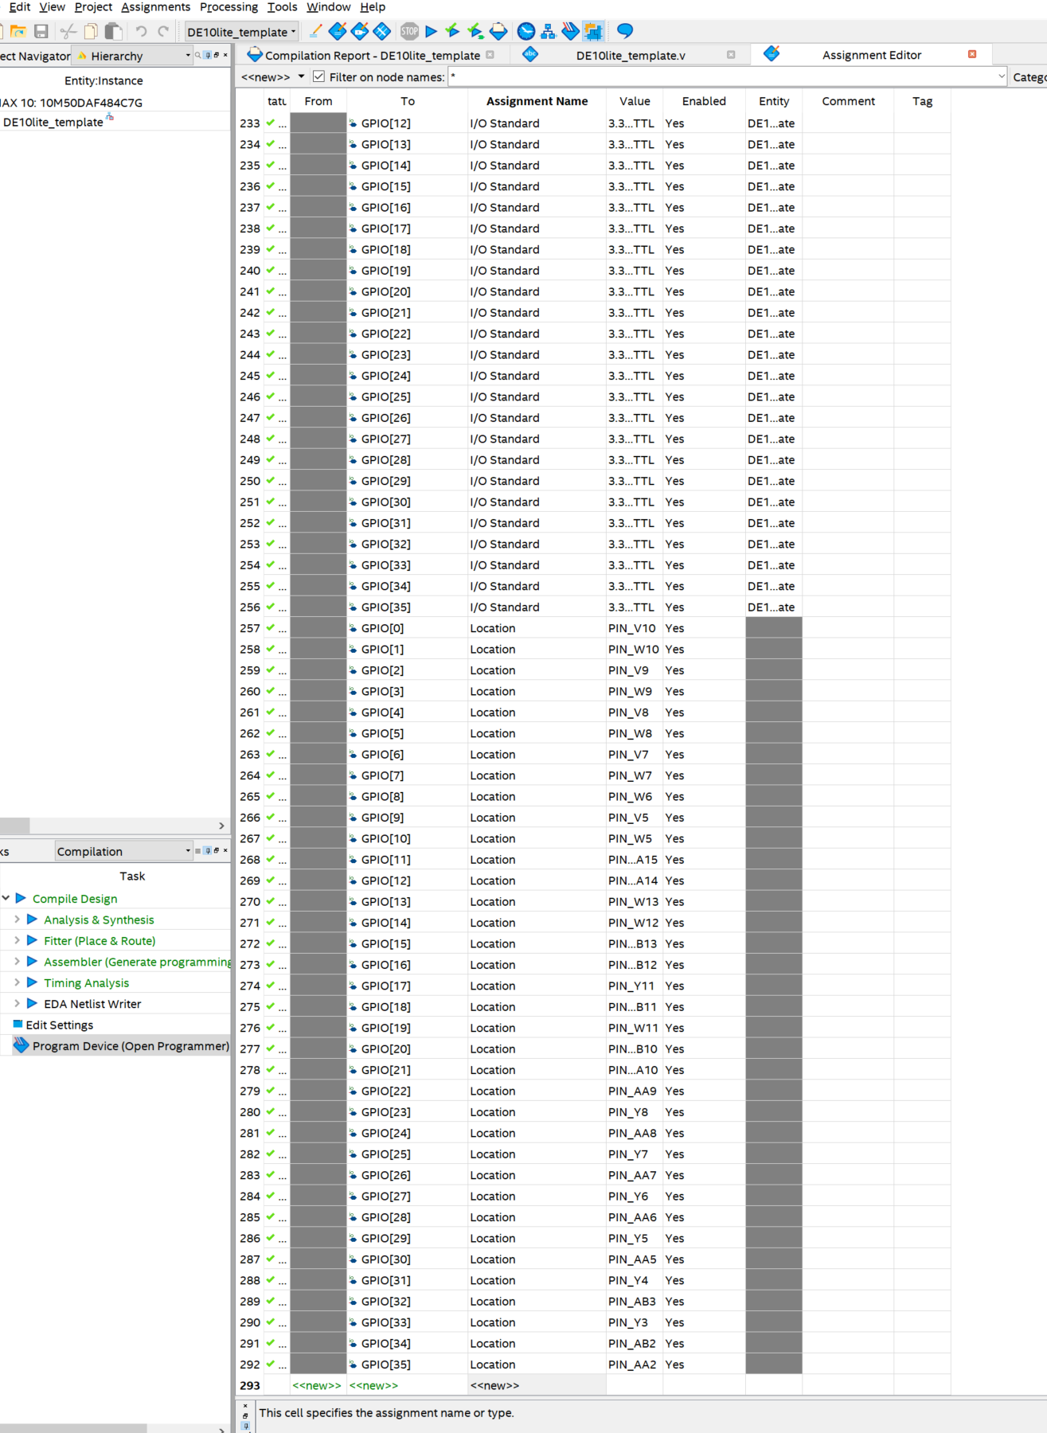

1. You can configure pins using Assignment Editor as well. For instance, if you need to apply a pull-up or pull-down resistor to GPIO[24], you could go under new and program it. (Don’t do it.)

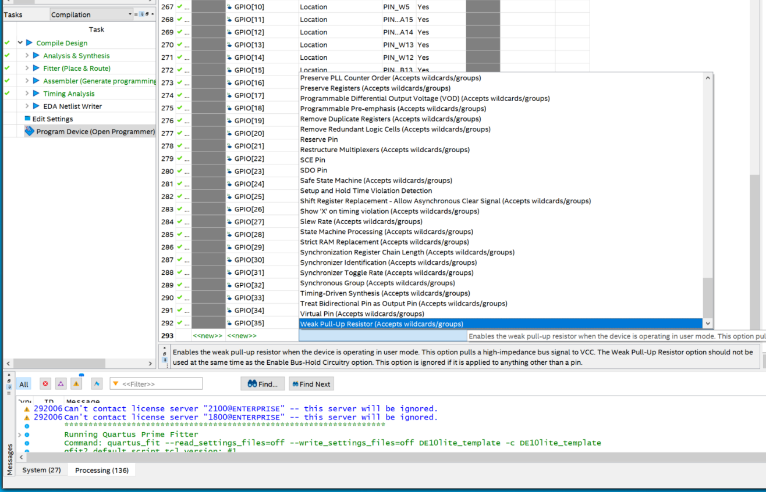

1. Please answer the following in a new word document.
   1. What is banking? How many banks are on this FPGA? Why is having different banks useful?
   2. There is an I/O standard setting that you can change. What’s the difference between 3.3V TTL and 3.3 V LVCMOS?
   3. What does changing the current strength do? Why would you want to increase or decrease the current strength?
   4. What does changing the slew rate do? Why would you want to change it?
   5. Do you always want the most current and highest slew rate? Why or why not?

## Pull-up/Pull-down testing the digital inputs on the DE10-Lite and Joystick board

1. **WARNING**! You need to turn off the board before plugging in the joystick shield to prevent damage to the board.

**WARNING**! You need to make sure you align the shield in the correct positions.

**WARNING!** There are no replacement shields. You will be responsible for ordering replacements on your own if you break your shield.

Correctly plug the joystick shield into the board. 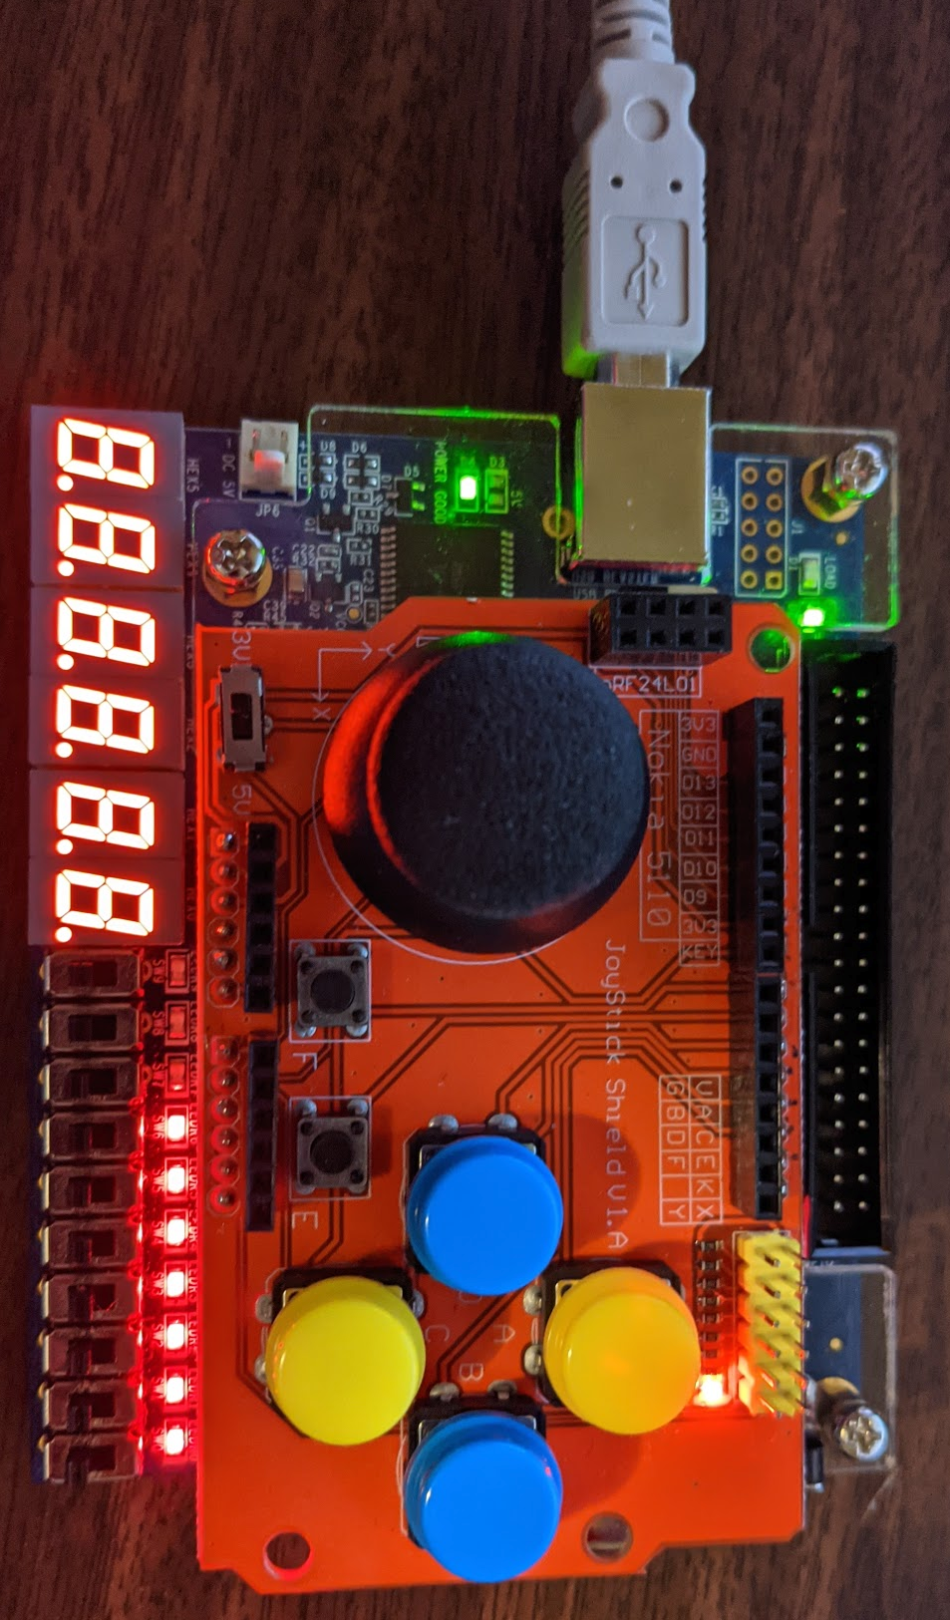

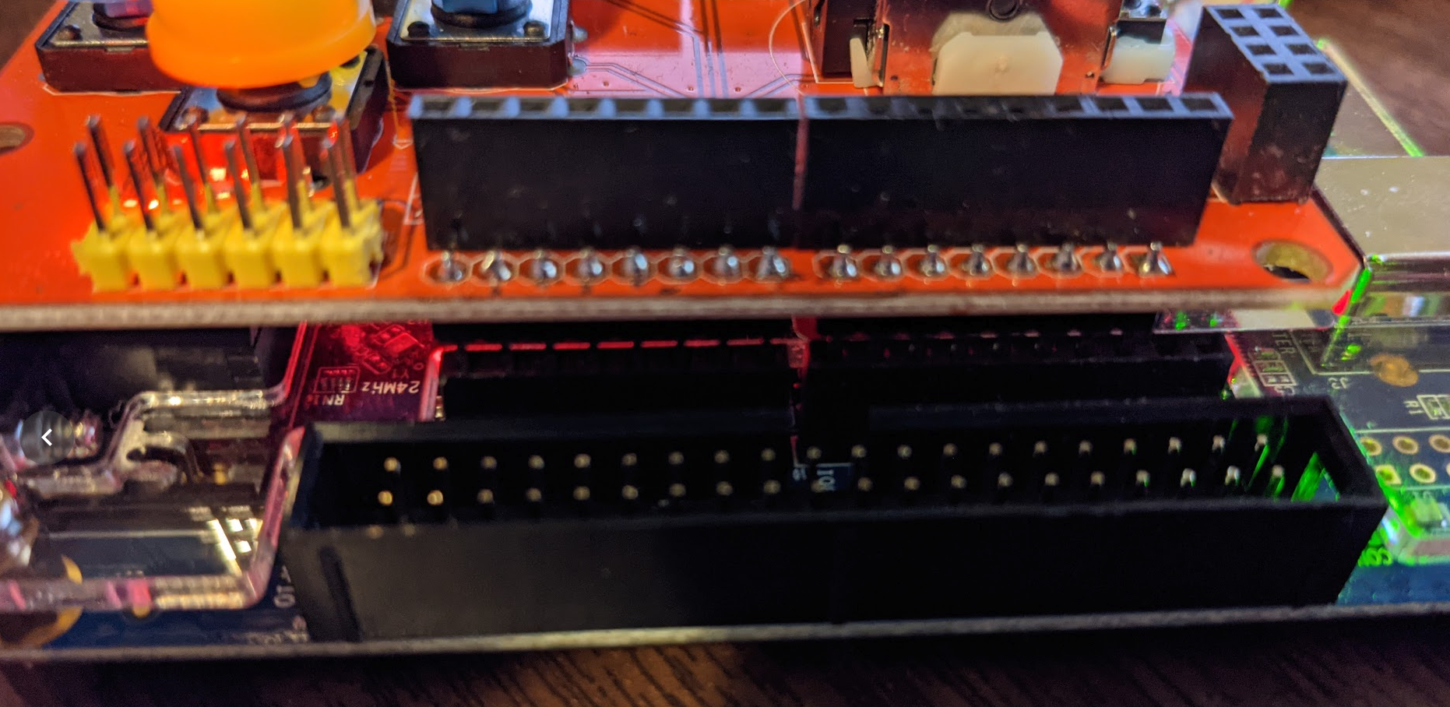

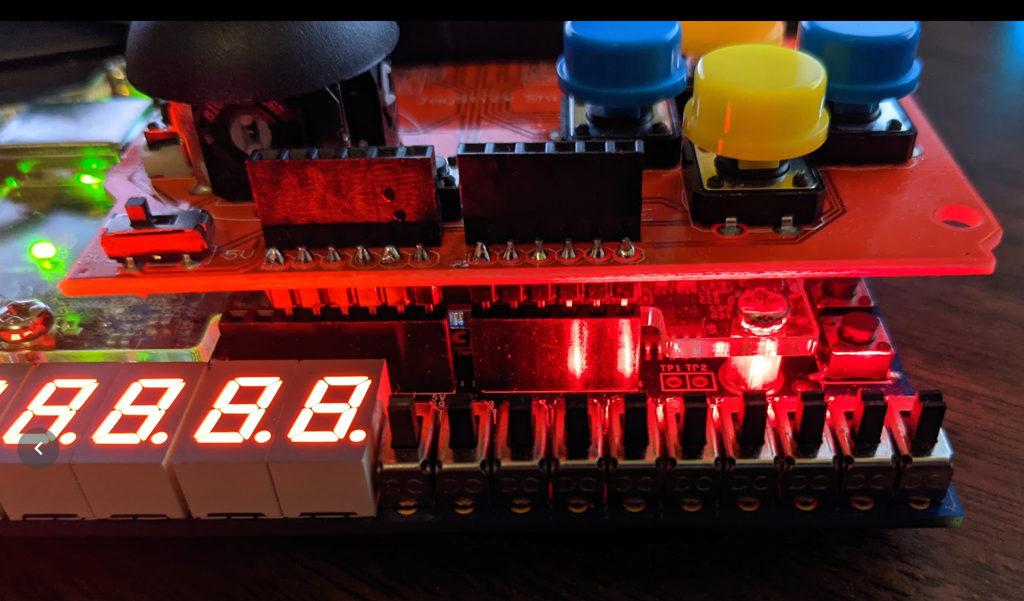

1. In the code section, let’s test that your buttons work.

Type in the following assign statement on line 65 to connect the LEDR[6:0] to the Arduino_IO headers. The ArduinoIO pins 2,3,4,5,6,7,8 are connected to the buttons. These buttons are active low. When pressed, they will pull to ground (logic 0), and when left alone they will be pulled up to the voltage source (3.3 V) (logic 1).

You need to also go to line 45 and 46, and change the arduinoIO into inputs only for now.

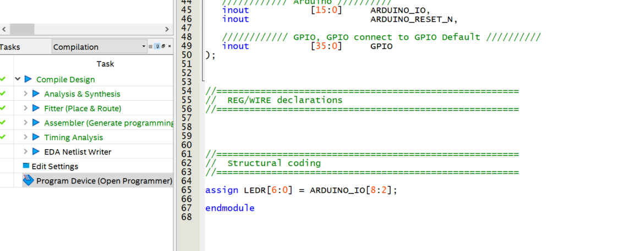

1. Questions: Please draw how a single button is connected to the FPGA using a pull-up resistor.
2. Question: What is the difference between pullup and pulldown? Please draw a single button using pull-down.
3. Question: Does the MAX10 FPGA have both internal pullups and pulldowns available? Where in the datasheet does it describe this functionality? Link or snipping is fine.
4. How would you enable an internal pull-up or pull-down?
5. Ok, now double-click compile design and program the device. 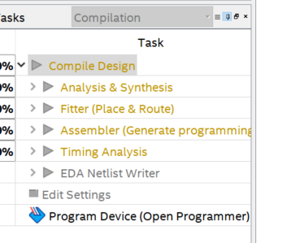
6. After it’s successful (If it’s red, it is not successful.) Double click on Program Device.
7. This window should launch. If you do not see USB-Blaster, might need to click on Hardware Setup and double click on the USB-Blaster.

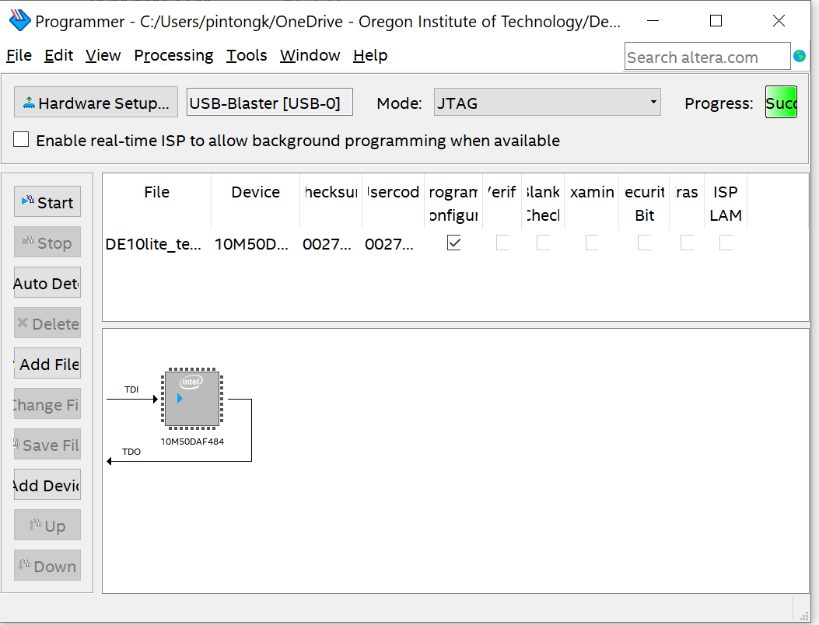

1. Click Start and then test that LEDS 6:0 are on. Press each button including the joystick. Each button should turn off the LED as it is pressed. Verify that this is the case and show instructor.

# Tristate usage

1. Let’s go back to line 45 and 46 and change them back to inout. Changing them to inout allows us to use the pins as inputs or outputs. But earlier, if you left them that way, it would not work. How to use tri-state?



1. We can’t just use the code below with the inout. It may not work.

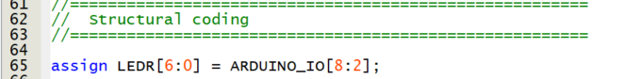

1. So what do we do? We need to implement tristate buffer.
2. Please draw one tristate buffer below and explain in your own words what tristate buffer is, and how tri-state works. This should have been covered in CST 133 and CST 162, but you can use the internet if you wish. **Just make sure that your answer is in your own words or drawing.**
3. Draw the tristate buffer
4. Explain what is tristate?
5. How does tristate work?
6. What could it be used for?
7. So, how does it work in Verilog? Copy and paste the code below and compile.

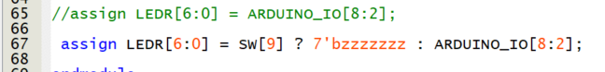

1. Please explain what line 67 is doing.
2. Ok, now demonstrate to your instructor tristate functionality.

# Configuring ADC IP

1. We discussed what IP was in class, and the ADC IP as well. The Joystick interfacing requires the use of an ADC because the joystick outputs two analog values. One is X0, the other is Y0, and they are assigned to A0 and A1 respectively. The ADC IP will read the value of X0 and Y0.
2. Answer the following
   1. How many bits ADC is the MAX10 built in ADC, and what is the sampling rate for this ADC? Give me a link to where you found this.
   2. How many channels does the MAX10 device on the DE10-Lite board support? Give me a link to where you found this.
   3. If an ADC is 10-bit resolution and the voltage range is 10 V, what is the step size of each value?
3. Go to IP catalog and double click on ADC Controller for DE-series Board IP core. 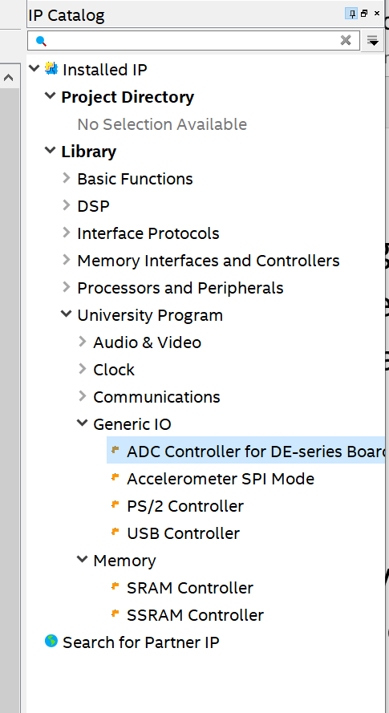
4. Call your ADC adc_1 and make sure you have the Target device selected as below. 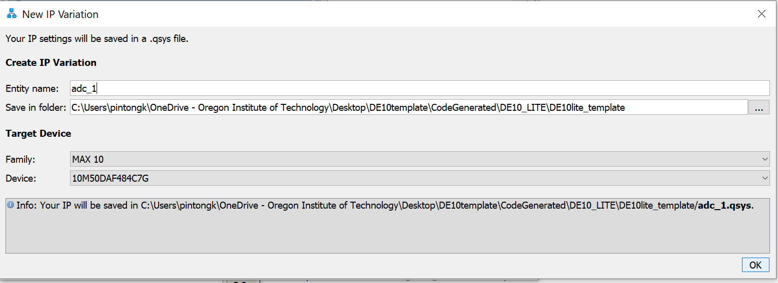
5. 5. Select the DE10-Lite board and make sure you select 2 channels, and 50 MHz system clock frequency. Then click Generate HDL.

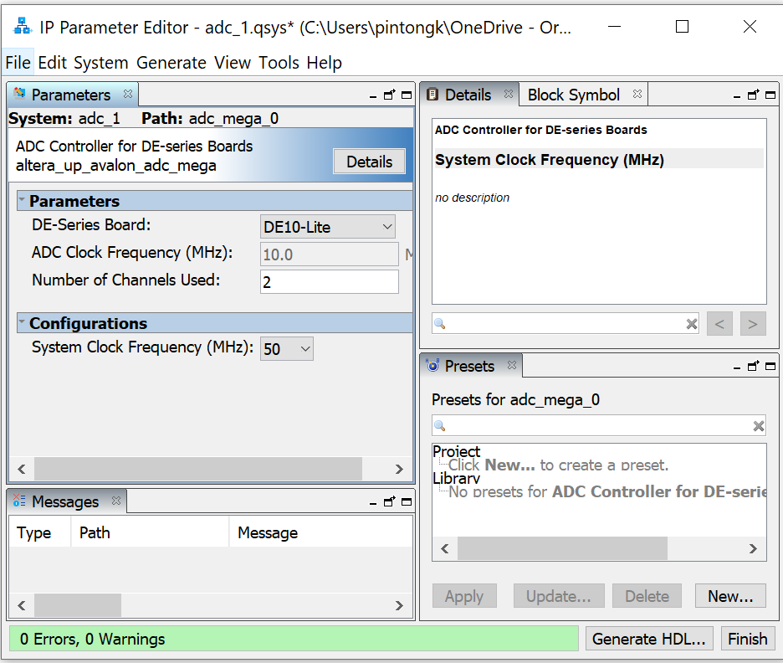

1. Make sure you select Verilog.

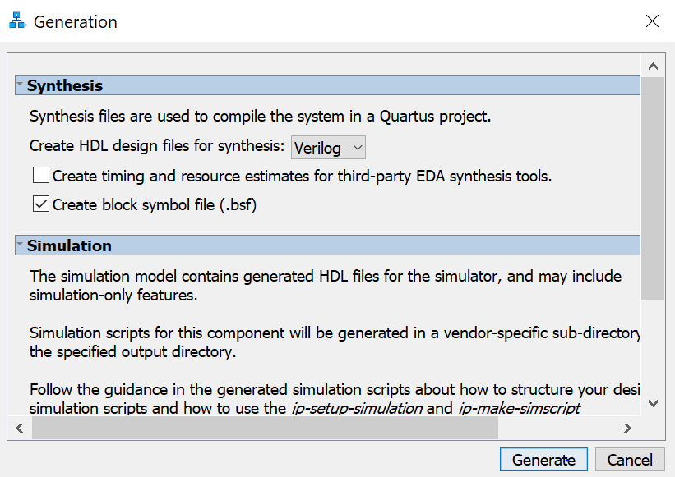

1. Go to project navigator and right click on the Files menu. Add the QIP file. 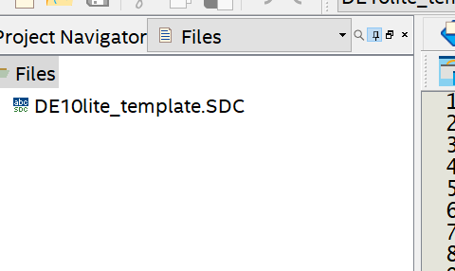
2. See the adc_1.qip file below? Add it. See the adc_1.v file below as well? Don’t add it, but go and open the file. It will be a template showing you what the Verilog module is called, and what needs to be fed in and out of the module.

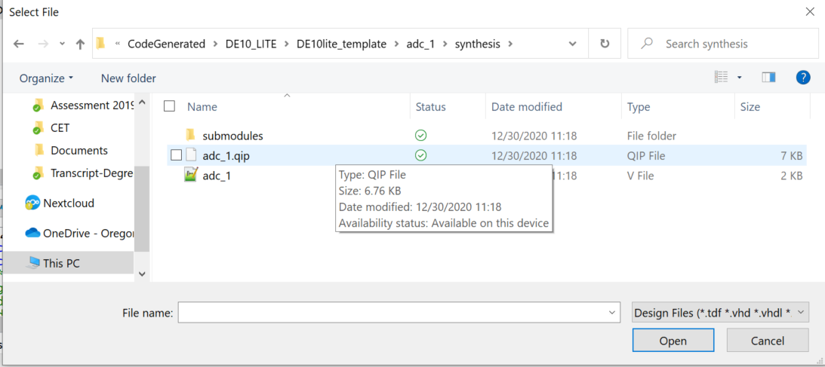

1. If you need to modify the IP core, you can open the qsys file using Platform Designer.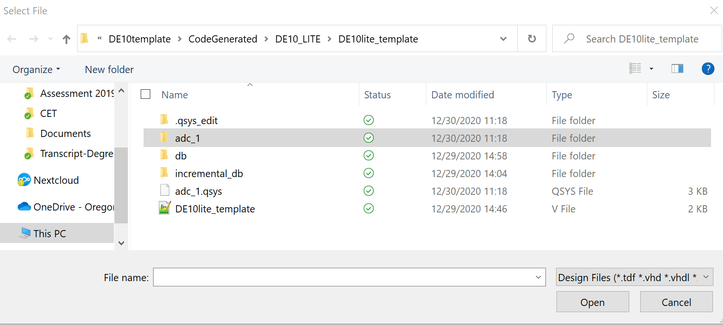
2. After adding, make sure the adc_1.qip shows up in the Project Navigator.

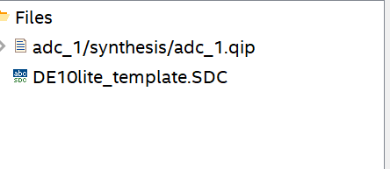

1. This is an example of how to instantiate the file. In this case, we need to feed signals into CLOCK and RESET. The X and Y axis will come out of CH0 and CH1 of the joystick. A0 and A1 are connected to X and Y axes respectively. CH0 and CH1 are both outputting 12 bits. 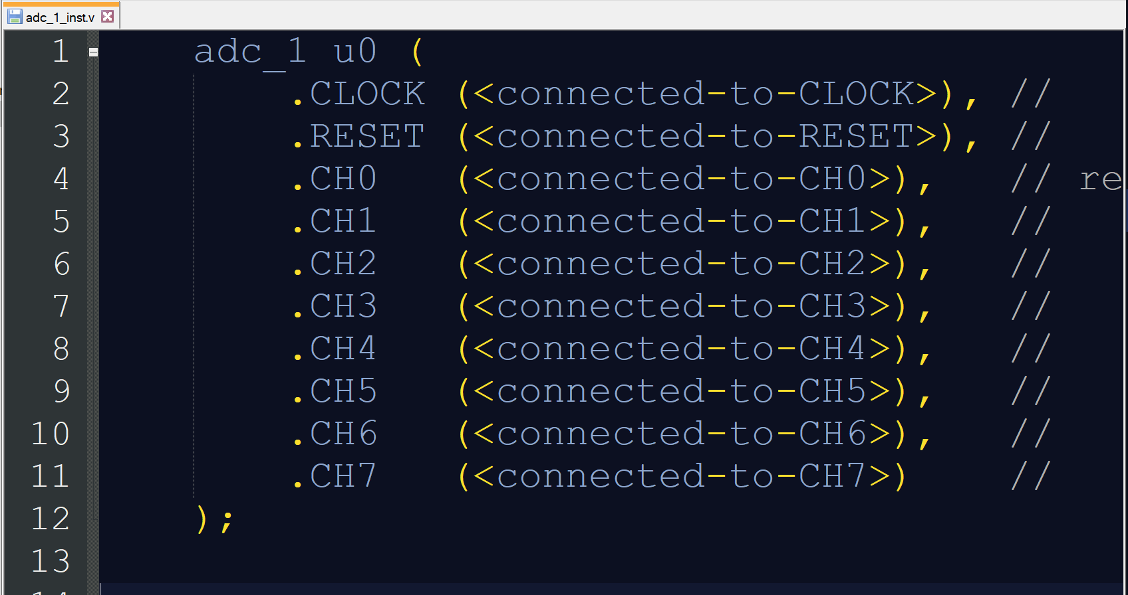



### Wire up the ADC IP.

1. In DE10lite_template.v (Or your top level file), instantiate a copy of adc_1 and wire it to ADC_CLK_10 and the respective reset, CH0, and CH1 signals. CLOCK is an input, RESET is an input. CH0 and CH1 are connected to the X and Y axis of the joystick on the board. CH0 and CH1 are 12-bit inputs to our module.
   1. You will need to feed the ADC_CLK_10 into CLOCK.
   2. You will need to make a 12-bit wire called X0 and connect to CH0.
   3. You will need to make a 12-bit wire called Y0 and connect to CH1.
2. Configure the board such that SW[6] selects between the X axis and Y axis. Since the ADC is returning a 12-bit value and we only have 10 LEDs on the board, use only the top 10 values.
   1. In other words, your signal is X0[11:0] coming from CH0. However, since LEDR[9:0] is only 10 bits, ignore the two LSB on X0 and Y0.
3. Record the values (Remembering that you can’t see the two LSB bits- just set them to zeros.)
   1. Right movement of joystick maximum value: _______________
   2. Centre (idle) joystick value for X axis: _______________
   3. Left movement of joystick maximum value_______________
   4. Centre (idle) joystick value for X axis: _______________
   5. Up movement of joystick maximum value_______________
   6. Down movement of joystick maximum value_______________
4. Demo to instructor the joystick functionality (indicated using LED and switch 6)
5. Question: What is the step size of each increment assuming 12 bit resolution and 5 V range?
6. Question: Jostling the board slightly will change the values slightly on the LSB side. Pressing the buttons will also cause the value seen on the LEDs to change. Why is this the case? Think in terms of step size and noise.
7. Question: It seems that the ADC can be somewhat noisy. If we were feeding the joystick input into another system (such as controlling a cursor or something), this could prove to be noisy. What ways can you think of to eliminate or filter noise?
8. Question: IP cores are pre-fabricated modules which allow us to access functionality of the board. Convenient. Any disadvantages to using IP cores in our design? Please highlight two disadvantages.

Submission

1. Go to Project > Clean Project.
2. Zip up your project and submit to Canvas.
3. Upload the answers highlighted in magenta to canvas. Please maintain the numbering assigned.